1. Launch Vivado

2. Click on Create New Project to start the Wizard
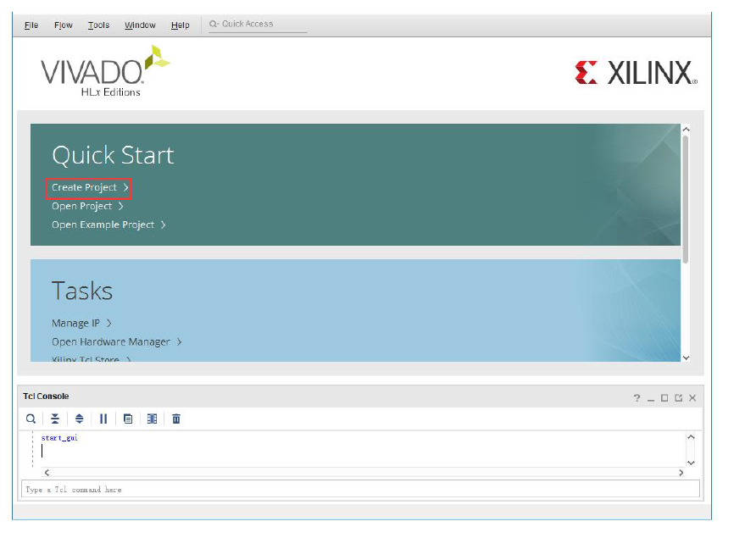
3. Click Next on the Create a New Vivado Project pop-up
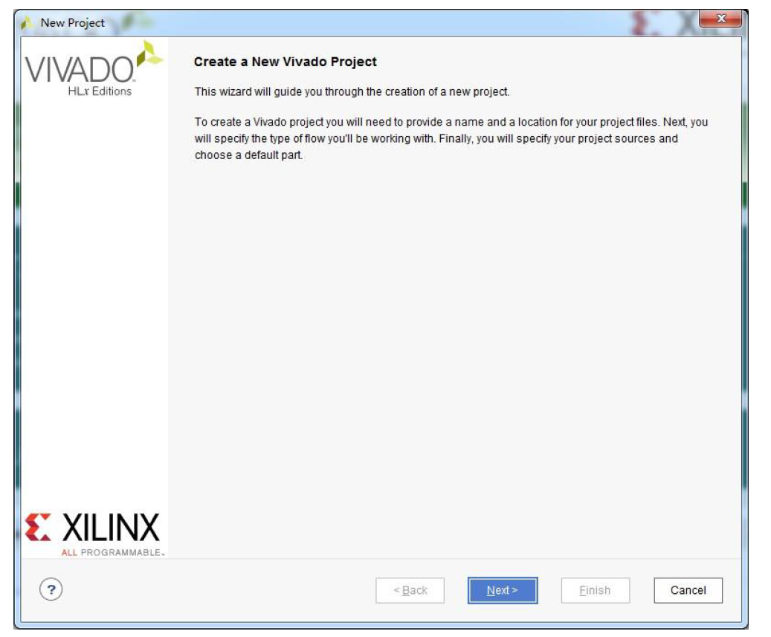

4. Enter the project name and directory in the Project Name pop-up. Note, Vivado will create a folder with the name you provide in the Project name box.
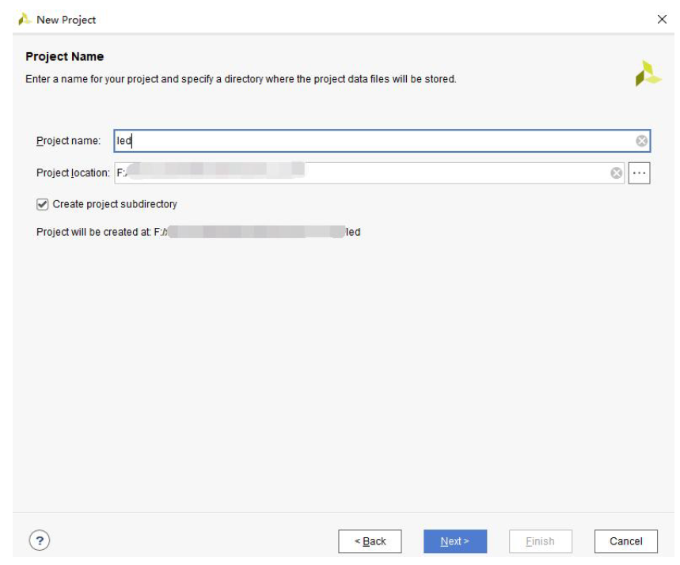

5. Select RTL in the Project Type pop-up.
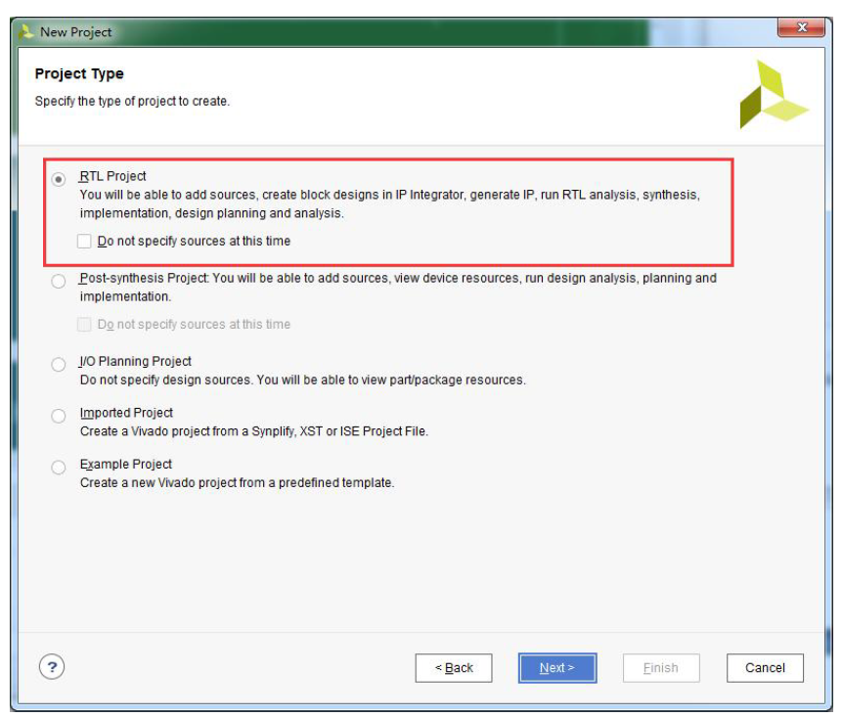

6. Select VHDL in the Add Sources pop-up.
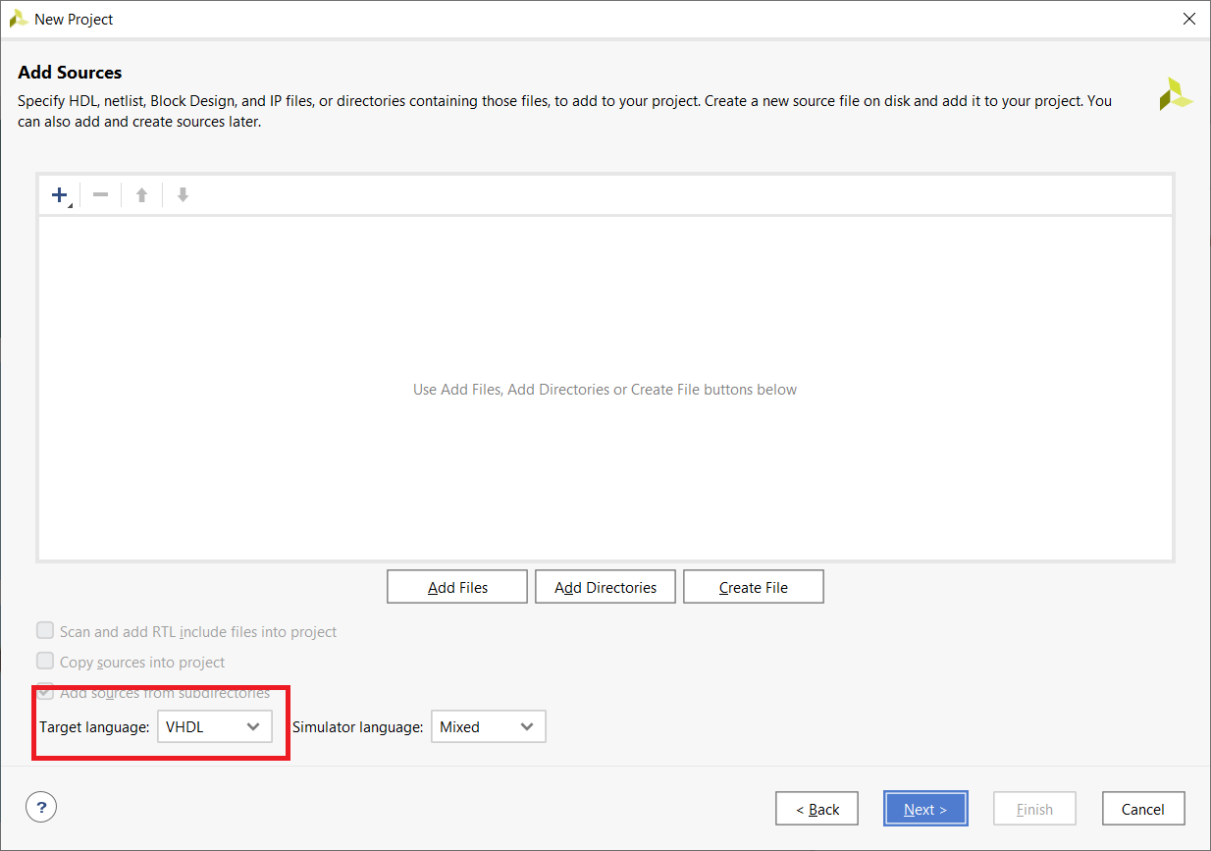

7. Don’t add any constraints in the Add Constraints pop-up.
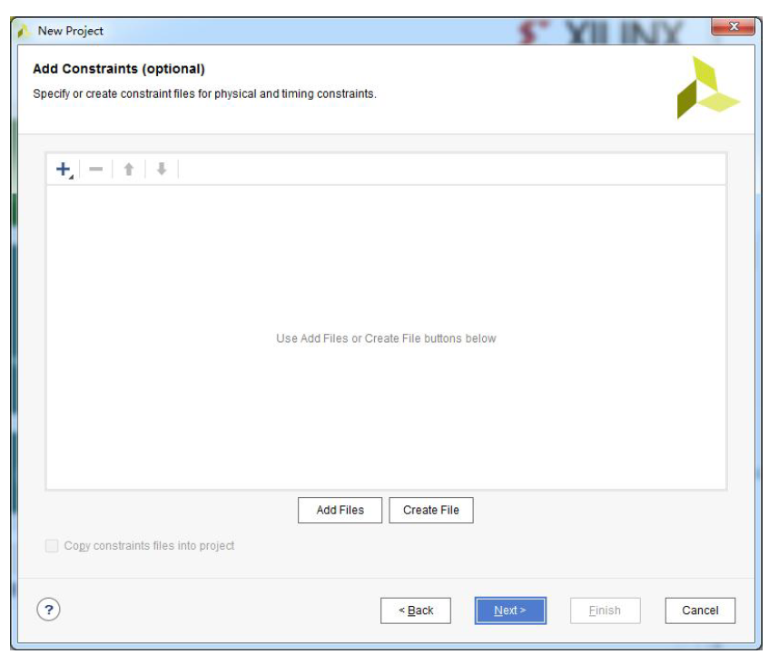

8. In the Default Part pop-up, select
Family: Zynq-7000
Package clg400
Speed grade: -1
Part: xc7z010clg400-1
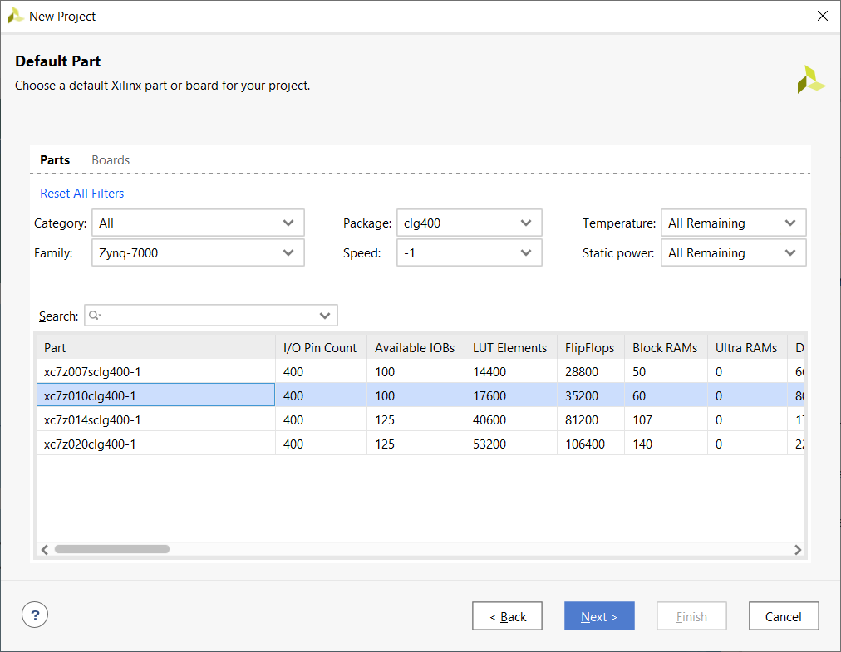

9. Click Finish in the New Project Summary pop-up.

